# GANPAT UNIVERSITY

# U.V.PATEL COLLEAGE OF ENGINEERING & TECHNOLOGY

# Department of computer science and engineering

# B.tech: 1ST sem subject:-ESFP-1

# First na:vardhman patel enrollment no:t14012101008 stream:CBA

# Practical-/assignment-1 DATE:27/08/14

Goal

Deliverable:

Source code:-

1).write a program to print ASCII values of all backslash characters and white space on screen in following format:

The ASCll value of ‘\t’ is : 9

(Hint: you can verify your ASCll values with the help of a table for ASCll values from text book)

2).Explain different data types available in C.

3).Explain about C Tokens in brief.

4).explain about backslash characters in C.

1)

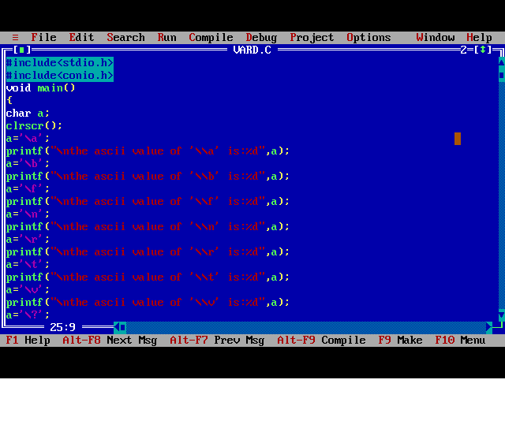

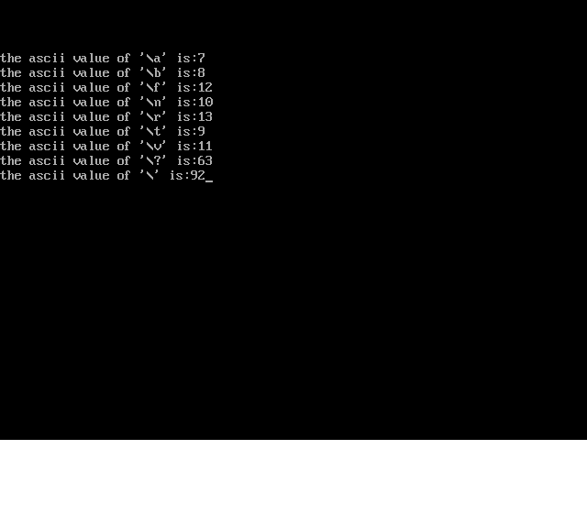

2).The variety of data types available allow the programmer to select the type appropriate to the needs of the application as well as the machine.

ANSI C supports three classes of data types:

1. primary (or fundamental) data types.

2. derived data types.

3. user-defined data types

The primary data types and their extensions are discussed in this section.

The user-defined data types are defined in the next section while the derived data types such as arrays, function, structures and pointers are discussed as and when they are encountered.

3) In a passage of text, individual words and punctuation marks are called tokens .similarly, in a C program the smallest individual units are known as C tokens. C has six types of tokens C has six types of tokens programs are written using these tokens and the syntax of the language.

1-KEYWORDS AND IDENTIFIERS

=>EVERY C word is classified as either a keyword or an identifier. All keywords have fixed meanings and these meanings cannot be changed. Keywords server as basic building for program statements.

The list of all keywords of ASCII are must be written in lowercase. some compilers may use additional keywords that must be identified from the C manual.

=>Identifiers refer to the names of variables, functions and arrays. These are user-defined names and consist of a sequence of letters and digits, with a letter as a first character. Both uppercase and lowercase letter are permitted, although lowercase letter are commonly used. the underscore character is also permitted in identifiers. It is usually as a link between two words in long identifiers.

=>constants in C refer to fixed values that do not change during the execution of a program.C supports several types of constants.

4)Backslash character c supports some special backslash character that are used in output functions. For example, the symbol ‘\n’ stands for newline character. A list of such backlash character constants is given in note that each one of them represents one character, although they consist of two characters. These characters combinations are known as escape sequences.

|  |  |
| --- | --- |
| constant | Meaning |
| ‘\a’ | Audible alter(bell) |
| ‘\b’ | Back space |
| ‘\f’ | Form feed |
| ‘\n’ | New line |
| ‘\r’ | Carriage return |
| ‘\t’ | Horizontal tab |
| ‘\v’ | Vertical tab |

|  |  |
| --- | --- |
| ‘\” | Singal quote |
| ‘\”’ | Double quote |
| ‘\?’ | Question mark |
| ‘\\’ | backslash |
| ‘10’ | null |